- This is a motor control. When it is state ‘off’, and we can run it by turn it on. When the time goes, it will be idle, but we can make it run again. Also, when the time goes again and be idle as well, we can turn it off.
- This is an automatic door. At first, it is locked. When the sensor detects movement, the door is opening, which means it is unlocked. 15 seconds later, it is closing. But when it is still unlocked, and when the sensor detects movement, it can be opening again, which means still unlocked. Again 15 seconds later, it is closing and 15 seconds later after the closing again, it will be locked.

- State : running
- Description: A Cassette player is running
- Event sequence that produces the state:
stopped
running
or
stopped
running
paused
running
- Condition that characterizes the state
When s [s ==”play”]
Events accepted in the state:
Event Response Next state
s, [s == “pause”] Start motor pause
s, [s == “stop”] Stop motor stopped

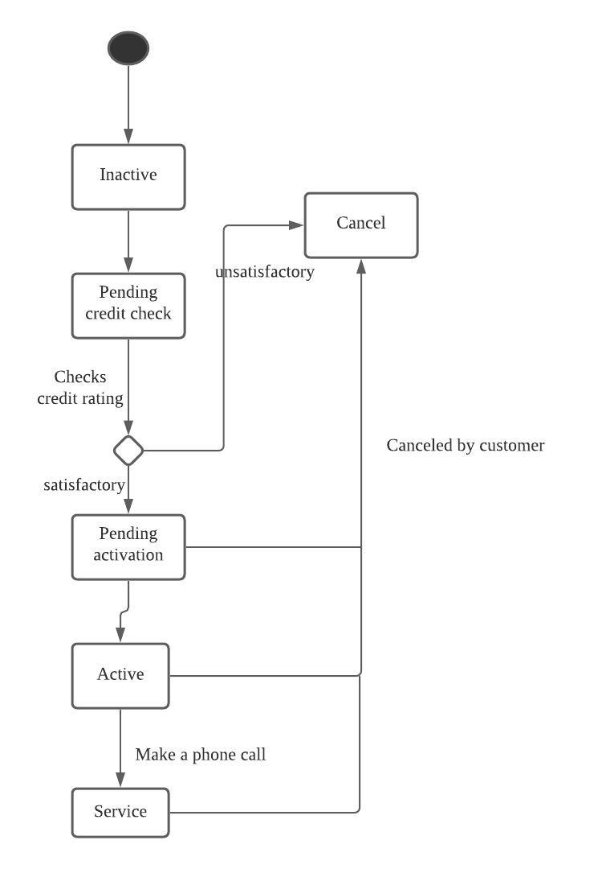

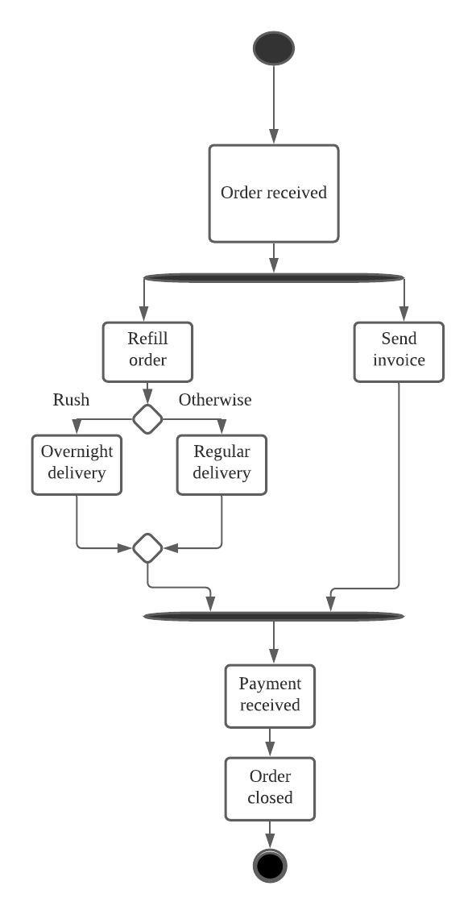

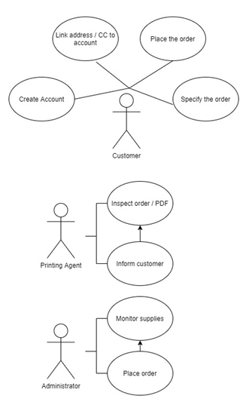
Use case : Place an order
Pre : User has account
Trigger : User to be able to place an order
Guarantee : Order is placed
Main :
- Send an order
- Information is identified
- Place an order
- Send Credit Card to bank
- Order done
Alternatives : Go back to step b if the information is missed by requesting it from the users.
Also, go back to step d when the credit card is not approved by requesting new credit card from the user

